Ultimate Battle Arena

Overall Game and Design Document

Frag Games (Private) Limited

Ultimate Battle Arena 1
Overall Game and Design Document 1
Frag Games (Private) Limited 1
Version Log 3
Introduction 3
Tagline 4
Scope 4
Game Overview 4
Game Concept 4
Target Audience 4
Genre 4
Game Flow Summary 4
Look & Feel 5
Gameplay and Mechanics 5
Ultimates 6
Classes and Roles 6
Factions 6
Ultimate Leveling 8
Card Packs 8
Battle Mechanics 8
Ultimate Ability Mechanics 9
Victory 9
Defeat 9
Formation Slots 9
Game Modes 11
PVE Game Mode 12
PVP Game Mode 12
Card Mechanics/Rules 12
Design Sheet: 12
Collections/Inventory 12
Deck Builder 12
Fusion 13
Re-Rolling 14
Chat System 14
Player Profile System 14
Leaderboard 15
Quests 15
Tutorial Level 15
Marketplace Integration 15
Tokens 15
Game Interface 16
Wireframes 16
Feature List 16
Asset List 16

Version Log
Version No. | Author | Description/Changes/Modification
0.1 | Fatima Afzal | Setup the game design sheet, skeleton.
0.11 | Fatima Afzal | Populated Tagline, Scope, Game Overview sections.
0.12 | Fatima Afzal | Populated Gameplay and Mechanics sections.  Ultimates  Card Packs  Battle Mechanics
0.13 | Fatima Afzal | Populated Gameplay and Mechanics sections.  The Battle Arena  Decks  Tutorial
0.14 | Fatima Afzal | Made Amendments to:  Tagline  Game Concept  Ultimates  Card Packs  Battle Mechanics  The Battle Arena  Card Rules  Fusion
0.15 | Sara Mirza | Amended:  Battle Mechanics  Deck Creation
0.16 | Fatima Afzal | Added: Game Modes  Updated: Deck Builder Screen, Chat System, Player Profile System, Inventory Management
0.17 | Fatima Afzal | Updated All Sections.  Added Feature List, Asset List
0.18 | Fatima Afzal | Updated All Sections

Introduction
The following document covers the Initial Game Design Concepts that will be fleshed out over the process of development. Please refer to the Version log for a list of changes/evolution.

Tagline
“Ultimate Battle Arena is a block chain game on the Polygon / Matic Chain Network that allows players to purchase, collect, fuse and sell ultimates.”

Scope
This design document comprises the technical aspects, mechanics, and narrative aspects of the gamified Ultimate Battle Arena application to be incorporated during pre-production, production, and post-launch periods.
- The game will be a basic 2-D version.
- The intent is to complete prototype development by December 2021.
- The game will be built on Unity WebGL.

Game Overview

Game Concept
Ultimate Battle Arena is an Axie Infinity-inspired universe where anyone can earn tokens through skilled gameplay and contributions. It’s a digital collection where players can battle, collect, modify and fuse their ultimates. Each ultimate has different stats which determine their role in the battle.

Each ultimate is a non-fungible token (NFT). Each is unique and owned by the user, validated through block chain, and its value can be appreciated or depreciated based on the marketplace. Since ultimates are tokens on a blockchain, they can be bought, sold, or transferred digitally, with a guarantee of ownership.

Ultimates have an infinite number of copies on the Marketplace. Each copy has distinct stats stored in a smart contract.

Target Audience
The intended audience for this game are people aged eighteen and above. Due to the legalities associated with cryptocurrency, and in-game purchases; audiences under 18 will be excluded from the target market. Instead the application will focus on a market that encompasses the following:
- Can partake in buying and selling cryptocurrency.
- Have an interest in blockchain and NFTs.
- Users who are interested in a more interactive form of crypto-trading.

Genre
The main genres of focus are: Non-fungible token, collectible card game.

Game Flow Summary
In Ultimate Battle Arena, players will collect, modify, and battle NFT-based ultimates to earn tokens through their gameplay and contributions to the digital world. Players battle against other non-player characters in teams of 10 Cards to earn Benders of Valor (BOV) Token, with battle outcomes determined by cards played and the type of cards fighting. Players can fuse ultimates to produce new and unique ultimates, requires BOV, and is limited in the number of times each card may be fused.

The core loop diagram:

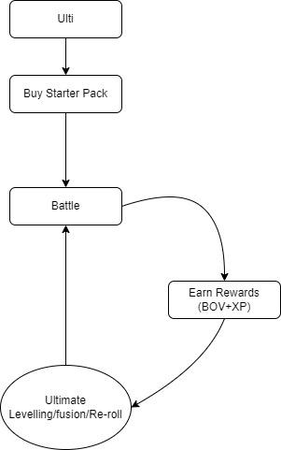

Look & Feel
The game would have Anime Art Style with a League of Legends Theme. Checkout this link for the game mood board: https://www.pinterest.com/babrusk/ultiarena/afk-arena-style/

Gameplay and Mechanics
In this section, each game mechanic will be fleshed out in detail:

Meta Mask Integration

Players need to authorize their wallet before starting the game. Using Meta Mask for the Wallet Connect which will act as a key vault, secure login, token wallet, and token exchange.
Check out detailed documentation here: https://docs.google.com/document/d/11fz5oCzMcH-mXK0Oti9z8R9359E4PM8lvSkJm0e65yQ/edit#

Ultimates
Ultimates are the characters the player can use in order to progress and participate in auto battles. Ultimates can be leveled up and possess abilities unique to themselves which allow for a good synergy among other ultimates. All ultimates belong to a faction, and are further distinguished with a Class, Type, and Role of their own.

Each Ultimate has the following set of animations: Idle, Attack, Hurt, Death and Special Animations.

The Ultimate Tiers are as Follows:

There are four different tiers of the Ultimates: Common, Rare, Epic and Legendary. Each tier has a maximum level cap of 50.

Classes and Roles

Classes: There are five different classes:

- Warrior
- Tank
- Mage
- Ranged
- Support

Roles: These roles will help us define character stats and abilities.

- Tank (Tank Class, Warrior Class)
- Heal (Mostly Support Class, sometimes Mage)
- Buff (Mostly Support Class, sometimes Mage)
- Assassin (Ranged Class, Warrior Class)
- Area of Effect (Mage Class, Ranged Class)
- Debuff (Support Class, Mage Class, Ranged Class)
- Damage over Time (Mage Class, Warrior Class, Ranged Class)
- Concentrated Damage (Mage Class, Ranged Class, Support Class)
- Crowd Control (Warrior Class, Tank Class, Mage Class)

Factions
There are four different avatar based factions.

- Water
- Earth
- Fire
- Air

- Water Faction:

Icon
Description: The water tribe are a peaceful bunch of people but can boil up if heated up too much. Careful, you don’t wanna get splashed on the face by getting too close!!

Factional Advantage: Health Bonus

No. of Playable Ultimates : 13

- Earth Faction

Icon
Description: Soft as the soil, hard as the rocks. The Earth Kingdom will provide you with the herbs they grow but watch out for those landslides!!

Factional Advantage: Armor Bonus

No. of Playable Ultimates: 18

- Fire Faction

Icon
Description: You know what they say, play with the fire and you will get burnt.

Factional Advantage: Attack Bonus

No. of Playable Ultimates: 11

- Air Faction

Icon

Description: Your relation with the Air Tribe determines if your flames extinguish or rise.

Factional Advantage: Spirit Bonus

No. of Playable Ultimates: 8

Ultimate Leveling
As the players approach higher levels, they would have to upgrade their ultimates to fight and win against stronger opponents. For that purpose, Ultimate Leveling is the feature used to level up the ultimates.

- By clicking on the “Inventory” icon found on the Main Menu Screen, users can navigate to the Inventory screen. The Inventory screen displays all the Ultimates the user has unlocked.
- Users can navigate to the Level-up screen by clicking on the Level Up button.
- On the Level-up screen, users can view the selected character’s rarity, name, level, attributes, class and roles.
- Users can click on the “Level-up” button to level the Ultimate one level at a time or hold down the “Level-up” button to continuously level the Ultimate, which consumes BOV until it reaches a milestone level.
- The ultimates can be upgraded to a maximum level of 50.

Card Packs
Card Packs are the most cost effective way to acquire cards.They offer the fastest way to extend the player's collection to a particular set. They contain items that players can open to acquire cards for filling a player’s UBA collection.
.
Card Packs can be purchased with ULTI Tokens. Each card pack contains 5 cards from the card set. Each card opened has a probability of being Common, Rare, Epic and Legendary but each pack is guaranteed to contain at least one card of at least a rarity.

Battle Mechanics
The Ultimate Battle Arena battle system is a turn-based card game where the goal is to eliminate all enemies your team of 10 cards is facing.

Visually, Battle Arena would be heavily inspired by the AFK Arena.
Check out detailed documentation here: https://docs.google.com/document/d/16U0ek_zM9AE_3s216fjsT_7NL7mSvEz_6tjU1cXuklg/edit#

Ultimate Ability Mechanics
Ultimate Ability Mechanics are as follows:

- The UA gauge will start off as empty (zero) at the start of the round
- When an ultimate's UA(ultimate ability) Gauge fills up, players can use Ultimate Ability. When it’s ready, it’ll auto attack.
- The UA Gauge will be dependent upon the number of turns. The gauge will fill up after 3 successful turns.
- Once the UA has been used, the UA gauge will reset to zero (empty) and will start filling up again and the cycle will repeat until the game ends.

Reference Video: https://drive.google.com/file/d/12ZqbsTeAducl1BafTDYX8RBwkkpwHzJE/view?usp=sharing

Victory
If the user wins the match, they should be shown a screen indicating the text ‘VICTORY!’ and the BOV Tokens would be displayed as a reward.

Defeat
If the user loses the match, they should be shown a screen indicating the text ‘DEFEAT’ and there won’t be any reward.

Formation Slots
In Battle Arena, there would be a maximum of 5 formation slots for cards. 2 Rows: Front End Queue and Back End Queue. Front End Queue would be utilized for the cards with high health and Back End Queue would be utilized for the cards with low health. Each slot would be class-specific.
Formation is as follows:
- Front End Slot 01 is for Warrior Specific Class
- Front End Slot 02 is for Tank Specific Class
- Back End 03 is for Mage Specific Class
- Back End Slot 04 is for Ranged Specific Class
- Back End Slot 05 is for Support Specific Class
Class wise priorities are as follows:
- Tank
- Warrior
- Ranged
- Mage
- Support

Role wise priorities are as follows:

- Tank (Tank Class, Warrior Class)
- Heal (Mostly Support Class, sometimes Mage)
- Buff (Mostly Support Class, sometimes Mage)
- Assassin (Ranged Class, Warrior Class)
- Area of Effect (Mage Class, Ranged Class)
- Debuff (Support Class, Mage Class, Ranged Class)
- Damage over Time (Mage Class, Warrior Class, Ranged Class)
- Concentrated Damage (Mage Class, Ranged Class, Support Class)
- Crowd Control (Warrior Class, Tank Class, Mage Class)
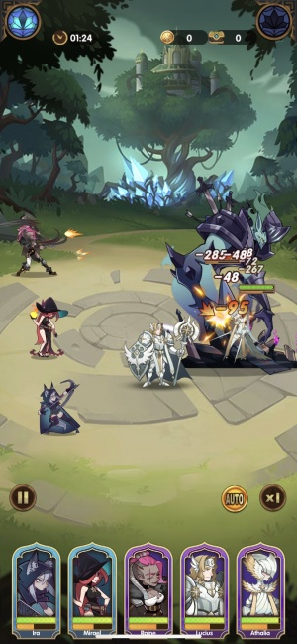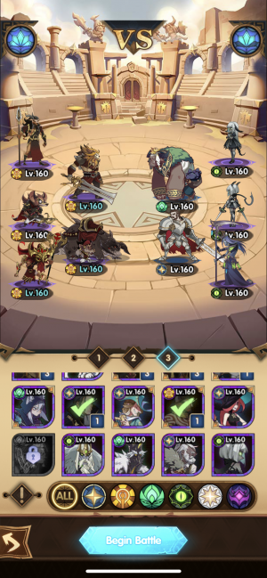Reference of a Battle Arena - AFK Arena

Game Modes
There are two game modes in Ultimate Battle Arena:

- PVE Game Mode
- PVP Game Mode

PVE Game Mode

The PvE game mode is a mode where the user is able to play against computer controlled preset decks.
As the core gameplay suggests, the battle would be automatic and there won’t be any reward.

PVP Game Mode

In the PvP game mode, the players are able to find online matches and compete with other online players. The users would preferably be matched against players of the same or almost the same level, so that the matches aren’t one-sided.

Check out detailed documentation here: https://docs.google.com/document/d/1Pv-Y6x19DJrfJH6z10Z_LPAkyAOiOlBAbXfPOsoAevk/edit#

Card Mechanics/Rules
Staying in the EBoH Engine, Card Rules would be modified according to our use case and would be defined in Metadata.

Design Sheet:
https://docs.google.com/spreadsheets/d/1H5MZXO7WqAgm4xwpmKPC6gInZpM8APU70yUPMfKu-88/edit#gid=565816390

Collections/Inventory
In the Ultimate Battle Arena Collection, players can go to view their collection of ultimates and card packs, construct and modify decks, reroll, level up ultimates and perform fusion of ultimates.

Check out detailed documentation here:
https://docs.google.com/document/d/1SWt9FqawAQvzHjgMeUnR26PLyPOq_a4gPyi0tAh2_pY/edit#

Deck Builder
A deck is a collection of exactly 10 cards assembled before a match. Players can create, modify and delete decks through the Deck Building Screen. Each deck takes up a deck slot, and the number of deck slots determines the maximum number of decks a player can own. Players start with basic and balanced decks, but can customize them and replace them with new and more powerful decks. Every card is unique, if the player has multiple copies of a single Ultimate, they will each have to be leveled up individually. By default, decks will be provided to the user after the first card pack purchase. There will be a maximum of 10 deck slots.
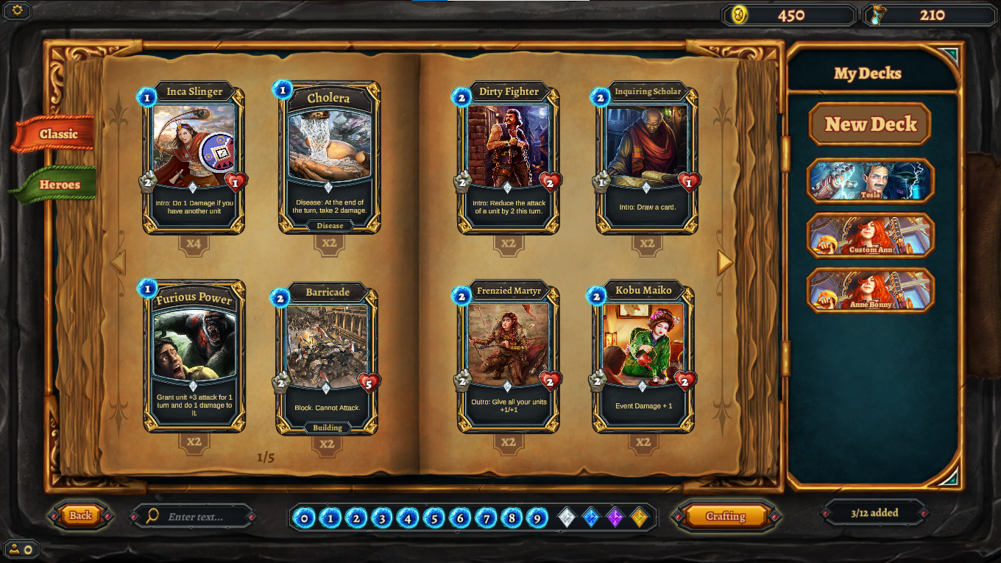
Reference of Collections Screen - EBoH

Fusion
In order to upgrade an ultimate’s tier, stats and level cap, the process of Fusion shall be used.

With that, player’s can take multiple cards of their ultimates and fuse them to become one much stronger card. Depending on which tier card is being upgraded, the requirements can vary.

Upon opting for Fusion:

- Player selects the ultimate they want to upgrade
- Upon selection, the player will then choose the next few cards (ranging from 2-3) which will be used to fuse and upgrade the previously selected champion
- Depending on the current tier of the ultimate, the requirements may either be cards of the same ultimate, or, when higher up, cards of the same tier.
- An amount of BOV will be required to fuse cards, the amount going up as the tiers go higher
- Upon selection of all cards and BOV burning, the fusion process begins
- The selected ultimate is moved up a tier, with their stats reflecting the upgrade
To get Legendary tier ultimates from Epic or even Rare rarity Level, they need to be fused to higher rarity levels to level up past their respective level caps.

Tier | Max level cap acquired | Requirements for Fusion
Common | Level 15 | Nothing fused to get common cards
Common to Rare | Level 30 | 2 copies of same ultimate at common
Rare to Epic | Level 45 | 3 copies of same ultimate at rare
Epic to Legendary | Level 60 | 3 cards of same ultimate at Epic

Re-Rolling
Players will have the option of re-rolling a card in order to get the best stats for an ultimate they own/have unlocked.

- The re-roll feature can be found on the inventory screen after the user selects a card.
- Using BOV tokens, the player can then re-assign the following stats to a card; health and attack.
- The stats will be randomized within a specific range, so there is a chance that the stats post re-roll may not be satisfactory to the player. However, they can continue to re-roll until the data suits them.
- There will be a limit to how many times the user can re-roll and the amount will reset after 24 hours.

Chat System
Chat is text based in Ultimate Battle Arena. Players can type a message and send it to their friends. Players can add/remove and search for friends. Players can match and request friendly battles with other players.

Check out detailed documentation here:
https://docs.google.com/document/d/1rBaWh7Z4shfRrGIXXGzO-AzfDJUh5T7gUhpuRHHYWE0/edit#

Player Profile System
Player profile will contain player’s information like the player's avatar, player’s name. A player can modify his avatar and name.
Stats will be:
- Overall Progress
- Wind Faction Collection Progress Bar
- Earth Faction Collection Progress Bar
- Fire Faction Collection Progress Bar
- Water Faction Collection Progress Bar
- Top Ranked Ultimate’s portrait
- User’s most used ultimate’s portrait in decks
- Current Battle Rank with icon
- Win Rate
- Win Streak
- Total Wins
- Total Matches

Check out detailed documentation here:
https://docs.google.com/document/d/1rBaWh7Z4shfRrGIXXGzO-AzfDJUh5T7gUhpuRHHYWE0/edit#

Leaderboard
Leaderboard is made up of players who have chosen to display their gameplay activities publicly.

Check out detailed documentation here:
https://docs.google.com/document/d/1rBaWh7Z4shfRrGIXXGzO-AzfDJUh5T7gUhpuRHHYWE0/edit#

Quests
A quest is a task that a player-controlled character may complete in order to gain a reward. In UBA, we’ve 3 different types of Quests: Mandatory, Daily and Weekly.

Tutorial Level
When the player logs in for the first time, ideally they would be given a small non-interactive tutorial that explains each and every facet of the game and what the player can and cannot do in game. Players can access this tutorial anytime. The tutorial can be skipped.

Marketplace Integration
For the Marketplace Integration, we’ll be using an external link to redirect users to the Ultimate Battle Arena Specific Section.

In the Game Menu, there’s a menu option ‘Marketplace’, clicking on it, will take players to the marketplace page where they can buy Ultimates and Card Packs using Ulti Tokens.

Tokens
There are two tokens in the Ultimate Battle Arena. The first is ULTI which is an BEP-20 governance token that allows (or will allow) holders to earn staking rewards, use for in-game payments, and participate in governance. The BOV Token is minted through gameplay as a reward to UBA players. The price of BOV depends on the growth of Ultimate Battle Arena, with the demand for card fusion and supply of BOV being key factors.

BOV Tokens can be traded on crypto DEX/CEX. If players don't want to use them, they can sell them.

Game Interface

Wireframes
Check wireframes here: https://pr.to/UQ2UJ1/

Feature List
- Input Controller
- Card AI
- Battle Mechanics
- Wallet Authorization
- Card Mechanics/Rules
- Player Profile
- Leaderboards
- Marketplace Integration
- Collections/Inventory Management
- Game Admin Portal
- Deck Builder
- Deck Selection
- Game Modes
- Fusion System
- Synergies
- Chat System
- Quests
- Tutorial
- Settings and Tool Tips
- Unity Crash Reporting
- Art Integration

Asset List
- UI (Wireframing, UI Production)
- Ultimates X 100
- Battle Boards X 4
- Card Frames X 16
- Icons
- Experiences
- VFX
- SFX
- Marketing Material

